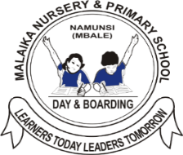**MALAIKA NURSERY AND PRIMARY SCHOOL END OF TERM III EXAMINATION 2023**

**TOP CLASS: (5 – 6 YEARS)**

**LEARNING AREA 3: HEALTH HABITS**

**My name is: ………………………………..………………………….**

**My School is: ……………………………..……….…………………..**

**I am in: ………………………………..…………………………………………..**

1. **Write the uses of the body parts**.

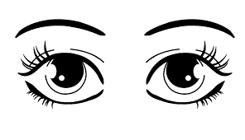

for _________________________

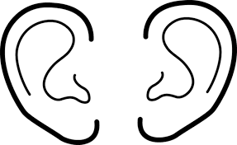

for _________________________

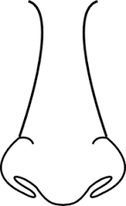

for __________________________

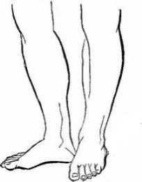

for __________________________

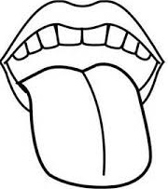

for __________________________

(hearing, smelling, seeing, walking, tasting)

1. **Draw these things we use to clean our body.**

|  |  |
| --- | --- |
| water | soap |
|  |  |
| toothbrush | comb |
|  |  |
| toothpaste | towel |
|  |  |

1. **Name the fruits we eat.**

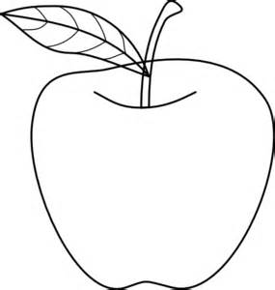

____________________

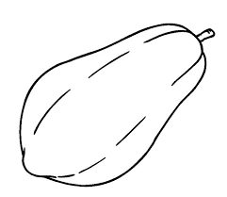

____________________

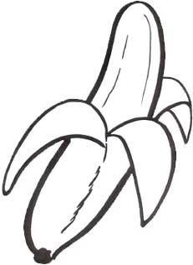

_____________________

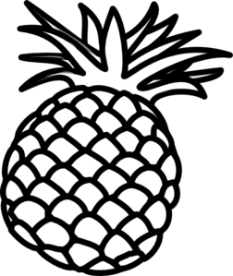

_____________________

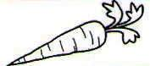 ______________________

(carrot, pineapple, banana, apple, pawpaw)

1. **Draw these types of food**.

|  |  |
| --- | --- |
| cassava | beans |
|  |  |
| matooke | fish |
|  |  |

***“Good Luck”***